iPhone 6 Expected Features

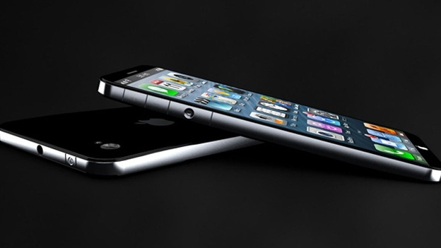
iPhone 6 concept design from T3.com

Rumours and speculations are starting to surface on the internet about the new iPhone 6. While nothing is official, there are some iPhone 6 features you can expect from the new iteration. Many users are expecting a lot from Apple, as the recent models of the iPhone have lacked the innovation that the original models showed. Will Apple play it safe, or ignite the smartphone market once again? Here are some expected features you will find on the iPhone 6.

Increased Storage Capacity

The new iPhone 6 will come with memory capacity options of 16GB, 32GB, 64GB and the new 128GB. With the increase in media, apps and memory that we use, Apple has created an iPhone that will cater to users who need more storage. The average user may not find this particularly useful or exciting, but there are people out there who would love more storage space on their iPhone.

Full 1080p HD Display

The screen size and resolution look like they might be in for a change. This includes a full 1080p HD screen that be able to play video in full high definition. Watching media on your new iPhone 6 is going to be better than ever before. Speculators have estimated a 1.2 to 1.5X increase in resolution. This will result in overall crisper displays and graphics.

More Colour Choices

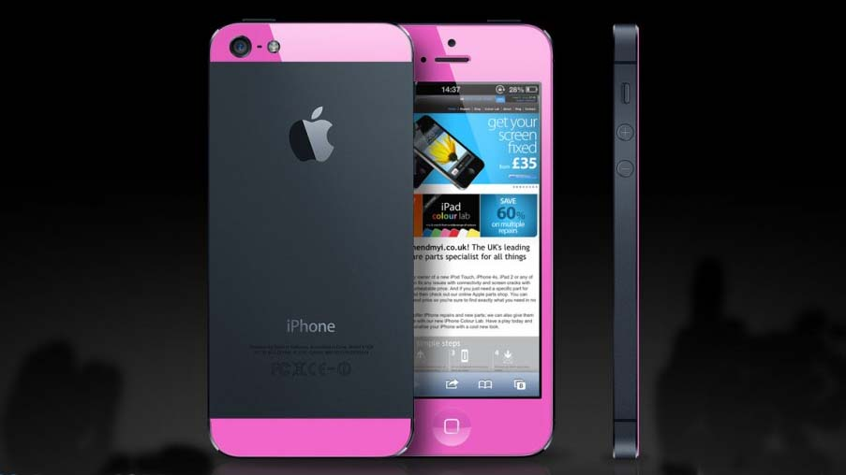
iPhone 6 colored models from Heavy.com

Following the popular trend of colored phone models, Apple is going to release a few variations of the iPhone 6. Usually there is either a white or black version, but we can expect a much greater variety of colors. It seems Apple is looking to spice up their products and inject some personality into them. There are also rumours that you can interchange between different colors but there is no official word on this yet.

Wireless Charging

There have been reports of Apple filing for a patent on wireless charging. While wireless charging isn't something completely new, it would be a great feature to the iPhone 6. Many users have complained about charging times and battery life, and this could be an elegant solution to that problem.

The wireless charging device may also be able to power several devices at once. Imagine being able to use your iPhone at work or home, and it will be constantly recharging so you never run out of battery life. This would be a great selling point for any smartphone, especially the iPhone 6.

Quad-core Processor

The current iPhones use the A5 dual-core processors, and they are already incredibly powerful. The iPhone 6 will most likely use the new A7 quad-core to increase performance. Not only will this improve the performance of any current apps, but it could open the doors for bigger possibilities to new apps and functions.

Stronger Scratch Resistant Screen

Apple has been using Gorilla Glass for many years on all their products. This heralds the release of Gorilla Glass 3 and it will probably see an appearance on the iPhone 6. Gorilla Glass 3 has a 40% reduction in visible scratches and a 50% boost in retained strength after the glass becomes damaged.

If you are interested in purchasing the iPhone 6, try our amazon coupon code for a discount and/or savings.

